Fletcher MUNC I
Historical Crisis Council
Preparation Guide

Fletcher Model United Nations Conference
Fletcher High School
February 3, 2018

Table of Contents

Role of the Council at FMUNC 3

Parliamentary Procedure 4

Actions and Voting Procedure 5
-Directives 5
-Communiqués 7
-Press Releases 9

Members of the Dias 10

The Flow of the Council’s Actions 11

Adapted from UCMUN HCC Prep. Guide 2015

2
Role of the HCC at FMUNC

At Fletcher MUNC I, the HCCs are functioning as regional bodies. In this format, they are structured in a way that is comparable to the Security Council, with the exception of having P5 members that hold veto power. Delegates will be representing countries and should focus their research on the foreign policies, laws, and historical precedents of their respective countries.

3
Parliamentary Procedure

Due to how fluid the HCC must be, the council’s parliamentary procedure is slightly altered to allow for faster responses than those from other councils. Here are the changes that are made for the HCC:
- There will be no speaker’s list. The council will mainly use moderated caucuses. Unmoderated caucuses and all other points/motions are allowed.
- Roundtables will be used. Roundtables are used to allow everyone to speak about a specific topic.
  - The speaking time is a minimum of thirty seconds and a maximum of two minutes.
  - The motion would be “I motion for a roundtable to discuss (topic).”
- Straw Polls. A non-binding vote that is used to gauge the opinion of the council.
  - The way to motion for a straw poll is to “motion for a straw poll on (proposal/directive).”
- Crisis Updates. During the conference, the crisis staff will introduce updates or new crises that the council must address through several means.

4
Actions and Voting Procedure
In the HCC, there are no resolutions. All actions by the council will be through directives, communiqés, and press releases. All actions must be formatted in the style of a normal resolution. Voting procedure works similarly to other councils.
Directives
Directives are short “right to the point” descriptions or actions you’d wish for the committee to perform and include none of the preambulatory and more filler or fluffy writing found in resolutions. Crisis updates will be occurring on a regular basis, and there is no time to formulate lengthy action plans. Despite this, they are binding and require clear and precise language concerning the actions the council desires to undertake.
- May utilize bullet points and contain only fragments if necessary but must be specific in detail.
- Are usually used as a reaction to a crisis update and will be responded to in following crisis updates.
- Two sponsors will be required. No signatories will be required.

5
- A delegate will motion to suspend the rules in order to have the chair read the directives in the order that they are received.
Example
Directive 1.1
Historical Crisis Committee
Cuban Missile Crisis
Sponsors: United States, United Kingdom

New orders for Minuteman I ICBM silo operators
● Arm all missiles on the United States Western Sea Board
○ No fire unless fired upon
● The United States will also scramble all fighter jets to assemble over Cuban Airspace

6

Communiqués
Communiqués are formal letters that can be sent to other actors, countries,
blocs, or the other HCC of the same topic. These can be negotiations, aid request, or opposition to certain actions. These are non-binding requests that require an appropriate tone and allows for lighter language.
- Letters to countries that are represented in the two councils will be given to said delegate for their response.
  - Letters to heads of states will be responded to by the crisis staff.
- Communiqués require only two sponsors and need a majority vote.

7
Example
Communiqué 1.1
Historical Crisis Committee
Cuban Missile Crisis
Sponsors: England and Portugal
Dear Premier Nikita Khrushchev,
It has come to our attention that you have placed nuclear-armed medium-range ballistic missiles in Cuba. This action is inexcusable and must be remedied immediately. Your placements are threatening the international peace and should be removed. Your actions are antithetical to the mission of the United Nations Security Council, which you serve on. We again demand that the missiles be removed from Cuba.

Sincerely,
The United Nations Security Council

8

Press Releases
Press releases are used to inform the public of what is going on with the current situation. Like communiqués, they represent the entirety of the council but require no actions to be taken within the press release. The usefulness lies in its ability to sway public opinion towards an idea or invoke a reaction by the public
- Is used to disseminate information, sway public opinion, cause outrage, drum up support, etc.
- Can publicize actions taken in previous objectives and may be voted in conjunction with another communiqué or directive.
- Does not require sponsor or signatories.

Example
Press Release 1
Historical Crisis Council A
Cuban Missile Crisis
Today, the Soviet Union has pushed the world to the brink of war by placing nuclear-tipped missiles on the island of Cuba. This provocative action by the Soviets is unacceptable and will not be tolerated. If the Soviet Union continues to threaten our sovereignty, we will take all actions necessary to ensure our safety.

9

Members of the Dias
In the Historical Crisis Council, there are several people who, in making up the Dais, help to ensure the council function smoothly.

The Chair
The role of the chair is to, in ensuring the council functions smoothly, maintain the flow of the committee as well as the approval of actions and motions throughout the session.

Crisis Staff
Crisis staff will work with the chairs to fulfill multiple functions within the council.
This includes:
- Reporting crisis updates that changes the actions and agenda of the council.
- Taking, monitoring, and responding to directives, communiqués and press releases.

10
The Flow of the Council’s Agenda
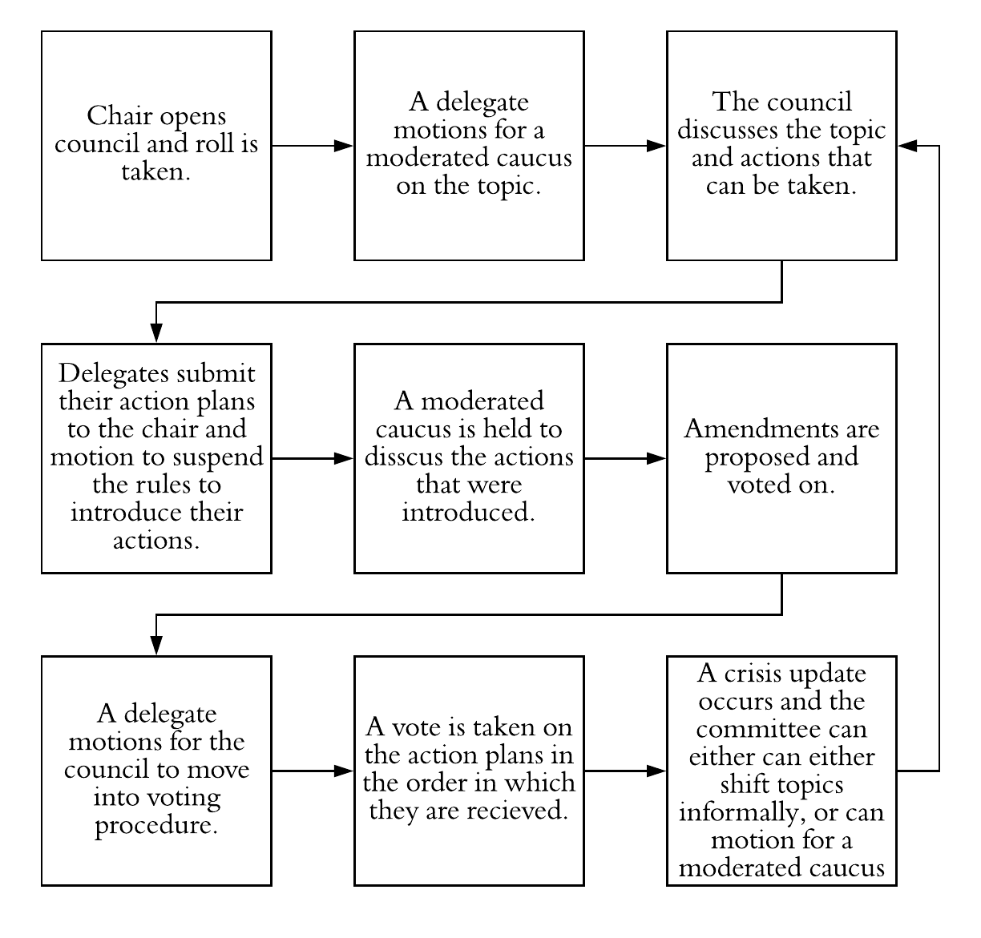

11

