Fletcher MUNC II
Historical Crisis Council
Weimar Germany
May 1924-1934
Background Guide

Fletcher Model United Nations Conference
Fletcher High School
February 8-9, 2020
Edited by: Lance Gabrielson

DISCLAIMER:
This Background Guide was sourced from the 2017 PACMUN conference, as this was a committee created on short notice. All credit for the background guide goes to chair “Julien Brinson” and his colleagues in PACMUN 2017. The current list of Senators has been updated. His original unedited guide can be found here.

Topics in Committee

Criminal Justice Reform

Brief Background

Policing

The United States has witnessed a series of high profile cases involving race and police activity.
The deaths of Eric Garner, Michael Brown, Tamir Rice, Walter Scott, Freddie Gray, Philando Castile, Alton Sterling and too many more exposed a troubling pattern between minority communities and the police forces that serve them. While each death is a tragedy, they were but the tip of the iceberg in a wider problem of a criminal justice in sore need for reform.

There are approximately 18,000 U.S. police agencies—including college campus patrols, sheriffs, local police and federal agents—of which 15,400 are local law enforcement, police and sheriff departments with armed officers. These agencies employ 765,246 sworn officers. Half of the law enforcement departments have fewer than 10 officers. Jurisdictions that can’t afford officers must contract with county police or neighboring agencies, which clouds accountability.

With these myriad of police departments, there is no standard for police training. When an uncooperative driver refuses to provide his license to a cop, officers in one jurisdiction may give them a warning, while in a neighboring jurisdiction, it could result in arrest or the use of force. Differences in policies and training mean that some cops can use pepper spray and Tasers on passive resisters while other departments only permit it when a person is physically resisting an officer.

District Attorneys are in a compromised position when asked to prosecute cops. The District Attorney works with local police officers on a regular basis. They may not intentionally show favor, but they may give their support to the officer unwittingly. In order for a case to go to trial, a defendant must be indicted by a grand jury. The grand jury only decides whether or not there is enough evidence to proceed to a trial—not whether or not the defendant is guilty. To secure an indictment, the DA—and the DA alone—can present any evidence they wish to the grand jury.

After the killing of Michael Brown in 2014 by police officer Darren Wilson, St. Louis County prosecuting attorney Robert McCulloch acted out of line with precedent. Since prosecutors can present any evidence they want to the grand jury, prosecutors almost always only present the most incriminating evidence. This way most cases get an indictment. According to the Bureau of Justice Statistics, of the 162,000 federal cases US attorneys prosecuted in 2010, grand juries only declined to return an indictment in 11 of them. However, McCulloch decided to present all the evidence, for every side, to the grand jury and would take no stand, nor play any role in the evaluation of that evidence. The grand jury failed to indict Darren Wilson.

Even beyond the rather egregious example of McCulloch, other grand juries and prosecutors have failed to indict police officers charged with wrongdoing. Actually, the likelihood of an indictment drops drastically when a police officer is involved. In Dallas 81 shootings came before grand juries between 2008 and 2012, and just on returned a verdict. In Harris County, Texas, a grand jury hasn’t indicted a Houston police officer since 2004. Grand juries have also failed to indict many officers involved in other high-profile cases as well.

Mass Incarceration

For a country with less than 5% of the world’s population, the United States has almost 25% of the total prison population. The American criminal justice system holds more than 2.3 million people in 1,719 state prisons, 102 federal prisons, 901 juvenile correctional facilities, 3,163 local jails, and 76 Indian Country jails as well as in military prisons, immigration detention facilities, civil commitment centers, and prisons in the U.S. territories. While the federal prison population only accounts for 197,000 people, federal policies and practices can be a guide for states to follow. Congress serves an important function in building trust and legitimacy between law enforcement and the communities they serve. The federal government annually provides billions of dollars and resources to law enforcement and the criminal justice system.

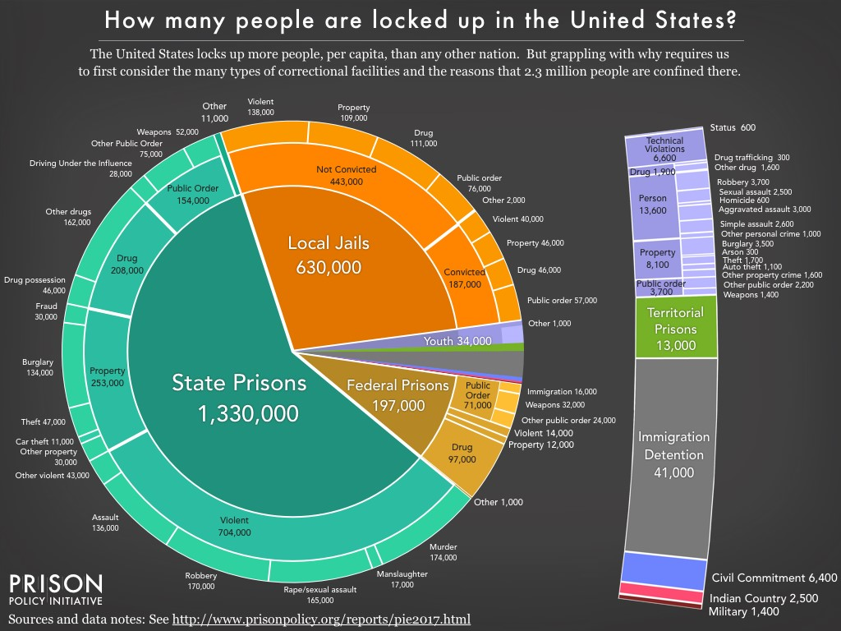

Counter to what some may think, crime rates are near the lowest levels seen in decades. Between 1980 and 2012, there has been a 35% drop in the violent crime rate and a 47 percent decrease in the property crime rate. However, while the nationwide arrest rate for all offenses decreased by 16 percent, the arrest rate for drug crime increased by 93.4%. Drug sale/manufacturing arrests increased by 55% and drug possession arrests increased 104.5% Arrests rates do not correlate with rates of offenses, but instead reflect the frequency with which crimes are reported, police decisions regarding offenses on which they will concentrate their attention and resources, and the relative vulnerability of certain crimes to arrest.

Over the past thirty years, the United States’ prison population has increased by 340 percent. In 2014, the state prison population was 6.4 times that of the federal prison population. In state prisons, violent offenders comprise 53% of sentenced prisoners and drug offenders make up 16% of the prison population. In federal prisons, drug offenders make up 50% of the population, while violent offenders constitute just 7 percent of the population.

The U.S. court system has struggled with fairly dispensing justice to the rich and poor. Everyone in the United States is entitled to free legal counsel, but since almost all criminal defendants are poor or near poor, in practice they receive ineffective counsel or virtually no counsel at all. The poor are defended by public defenders or by court-appointed private counsel, and both types of attorneys simply have far too many cases in any time period to handle them adequately. Many poor defendants see their attorneys for the first time just moments before a hearing before the judge. Overworked, the defense attorneys don’t have the time or resources to consider the complexities of any one case, and most defendants end up pleading guilty.

A 2006 report in New York concluded local governments were not fulfilling their constitutional obligations in providing legal representation to the poor. Some New York attorneys had an average caseload of 1,000 misdemeanors and 175 felonies. In addition, many poor defendants in 1,300 towns and villages throughout the state received no legal representation at all.

In Louisiana, it’s worse. Louisiana public defenders is in a crisis. 80% of criminal cases are handled by public defenders in Louisiana, yet the public defenders do not have the necessary resources to adequately meet the constitutional rights of their defendants. Public defenders have to perform their own jobs as well as social working and investigations. The public defender in New Orleans outright stopped taking new felony cases, so people accused of serious crimes were put on a waiting list for a lawyer. Thirty-three of the state’s forty-four judicial districts say they cannot keep up with the caseloads. With a lacking apparatus for public defense, the Louisiana court system works as mill processing people to prison. Louisiana has the highest incarceration rate in the country and the one of the highest exoneration rates, but it’s not alone when it comes to a chronic shortage of public defenders.

The U.S. court system guarantees every defendant the right to a jury trial. However, most defendants plead guilty and criminal trials are exceedingly rare (<3%). This plea bargaining allows prosecutors to ensure a conviction while saving the time and expense of jury trials. Defendants take the plea bargain because they help ensure a lower sentence than they might receive if they exercised their right to a trial and were then found guilty. In effect, this practice means that defendants are punished for exercising their constitutional rights, which coerces defendants to plead guilty even when they have a good chance of winning a not guilty verdict if their case went to trial.

Demographics in Prison

Men comprise over 90% of the U.S. incarcerated population, but the proportion of incarcerated women has grown at almost twice the rate of men since the 1990s.
The United States incarcerates a disproportionate number of black and Latino individuals relative to their composition in the U.S. population.

76.6 percent of offenders recidivate within five years of being released from prison. Upon being released from prison, an individual faces legal barriers to employment, housing, and voting. Cyclical incarceration imposes.

While women make up a relative small population of those incarcerated, women—especially women of color—are the fastest growing population of incarcerated people in the US. Since 1970, the number of women in US jails has increased by 14 times, far outstripping the already large growth in the male prison population. Women tend to enter jails in more vulnerable situations than men, as a higher percentage of women in jail were using drugs, unemployed or receiving public assistance at the time they were arrested. About one-third of all women in jail have a serious mental illness, such as schizophrenia, bipolar disorder or major depression—more than twice the rate that exists for jailed men and about six times that of women in the general public.

Also despite women’s relatively small share of the incarcerated population, women make up more than two-thirds of the victims of staff-on-inmate sexual victimization. 86% of women in jails reported experiencing sexual violence at some point in their life, roughly four times the rate of women in the US at large. Among the jail population, most people have not been convicted of any crime and are awaiting trial. The vast majority of women in jail have been charged with nonviolent property and drug crimes, and so-called “public order” offences, which include prostitution.

Since women have represented a smaller minority of people coming in contact with the criminal justice system, the system doesn’t take into account for the differences that women bring to the system. About 80% of the women in jails have dependent children and criminal justice fees and fines can have a long-term detrimental effect on the financial and physical wellbeing of these households. In a majority of these cases, the mother is a single mother.

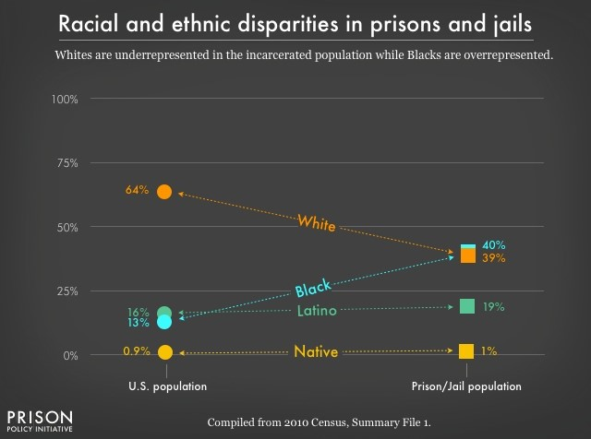
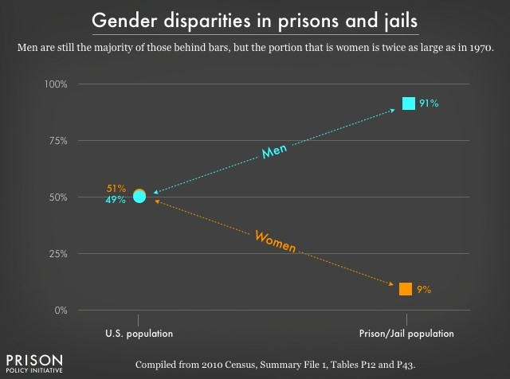

Private Prisons

While the Obama Administration began making moves to phase out the use of private prisons for federal inmates, the move was quickly undone by Attorney General Jeff Sessions. Private prisons typically cut cost for necessities and need not spend anything on prisoner training programs to maximize their bottom line. The safety of guards and inmates also is jeopardized as less is invested in security measures and personnel development. An Office of the Inspector General reported noted that privately operated prisons have higher rates of assaults—both prisoner on prisoner and prisoner on staff—than federally run facilities.

The private sector first entered the world of incarceration in 1983 and since then a handful of companies quickly began to exert a disproportionate amount of power in shaping the American prison landscape. Corrections Corporations of America (C.C.A.), the largest for-profit prison company in the United States, explicitly that changes to drug laws and sentencing, as well as immigration reform, would hurt its business. A 2005 annual report from C.C.A. states:

Our growth is generally dependent upon our ability to obtain new contracts to develop and manage new correctional and detention facilities. . .. The demand for our facilities and services could be adversely affected by the relaxation of enforcement efforts, leniency in conviction and sentencing practices or through the decriminalization of certain activities that are currently proscribed by our criminal laws. For instance, any changes with respect to drugs and controlled substances or illegal immigration could affect the number of persons arrested, convicted, and sentenced, thereby potentially reducing demand for correctional facilities to house them.

A private prison operated by the Geo Group, Inc., the second largest private prison company in the country, in Mississippi had horrendous abuses. At a facility holding teenagers, the GEO staff peddled drugs to the teenagers in their custody and subjected them to brutal beatings, sexual exploitation and solitary confinement.

According to a 2013 analysis found that two-thirds of private-prison contracts in the country include occupancy guarantees and stipulations that taxpayers cover the cost of any empty beds. States sign agreements with private prisons to guarantee that they will fill a certain number of beds in jail at any given point—commonly 90%. This creates an incentive for states to keep prisons full at all times. To do that, they incarcerate more people and for longer periods of time to fill the quota.

Even in government-run prisons, private companies operate in a number of capacities. In California, for example, Corizon Health, a private, for-profit health-care firm that services more than three hundred and twenty thousand inmates in twenty-five states, was sued for failing to provide adequate care to a prisoner who died under the company’s supervision. Corizon was found to have used licensed vocational nurses in a role meant for registered nurses, a decision that saved Corizon thirty-five per cent on the salary of each nurse. Corizon brings in a reported $1.5 billion a year and operates in four hundred and twenty-nine correctional facilities. An earlier, separate lawsuit resulted in a searing 2012 report on Corizon’s work with the Idaho Department of Corrections, which found that the company’s delivery of medical and mental health care either resulted in or risked serious harm to prisoners. The report states that authorities responsible for the administration of health care were “deliberately indifferent to the serious health care needs of their charges.” Both cases ended in settlements.

War on Drugs

In the 1960s, as drugs became symbols of youthful rebellion, social upheaval, and political dissent, the government halted scientific research to evaluate their medical safety and efficacy. In June 1971, President Nixon declared a “war on drugs,” as he dramatically increased the size and presence of federal drug control agencies, and pushed through measures such as mandatory sentencing and no-knock warrants. A top Nixon aide, John Ehrlichman, later admitted:

“You want to know what this was really all about. The Nixon campaign in 1968, and the Nixon White House after that, had two enemies: the antiwar left and black people. You understand what I’m saying. We knew we couldn’t make it illegal to be either against the war or black, but by getting the public to associate the hippies with marijuana and blacks with heroin, and then criminalizing both heavily, we could disrupt those communities. We could arrest their leaders, raid their homes, break up their meetings, and vilify them night after night on the evening news. Did we know we were lying about the drugs? Of course, we did.”

Nixon temporarily placed marijuana in Schedule One, the most restrictive category of drugs, pending review by a commission he appointed led by Republican Pennsylvania Governor Raymond Shafer. In 1972, the commission unanimously recommended decriminalizing the possession and distribution of marijuana for personal use. Nixon ignored the report and rejected its recommendations. Nixon laid the ground work for ramping up the drug war in the 1980s.

Under President Ronald Reagan, the incarceration rate began to skyrocket largely thanks to the huge expansion of the drug war. Between 1980 and 1997, the number of people behind bars for nonviolent drug law offenses increased from 50,000 to 400,000. Through media portrayals and the Nancy Reagan’s highly-publicized anti-drug campaign, “Just Say No,” the political and social ground was set for the zero tolerance policies implemented in the mid-to-late 1980s. The increasingly harsh drug policies also blocked the expansion of syringe access programs and other harm reduction policies to reduce the rapid spread of HIV/AIDS. Congress and state legislatures passed a series of draconian penalties that rapidly increased the prison population.

Since the 1980s, federal penalties for crack were 100 times harsher than those for powder cocaine, with black Americans disproportionately sentenced to much lengthier terms. Crack cocaine is one of the few illicit drugs that’s more popular among black Americans carries the harshest punishment. The threshold for a five-year mandatory minimum sentence of crack was for 5 grams. In comparison, the threshold for powder cocaine, which is more popular among white than black Americans but pharmacologically similar to crack is 500 grams. (The Obama Administration reduced the sentencing disparity from 100:1 to 18:1, but there is still a disparity.)

Bill Clinton’s presidency only exacerbated the situation. President Clinton rejected a U.S. Sentencing Commission recommendation to eliminate the disparity between crack and powder cocaine sentences, and he also rejected advice to end the federal ban on funding for syringe access programs.

Despite growing pressure against the War on Drugs, President George W. Bush continued the policies of his predecessors. The Bush Administration shifted their focus to marijuana and launched a major campaign to promote student drug testing. In the wake of 9/11, the Bush administration also began equipping domestic law enforcement with military-grade equipment. The equipment was supposed to be used to fight terrorism, but most of it was used to fight the war on drugs. At the end of the Bush years, there were about 40,000 paramilitary-style SWAT raids on Americans every year—mostly for nonviolent drug law offenses, often misdemeanors.

The drug war has produced profoundly unequal outcomes across racial groups although rates of drug use and selling are comparable across racial lines. People of color are far more likely to be stopped, searched, arrested, prosecuted, convicted and incarcerated for drug law violations than whites. Higher arrest and incarceration rates for black Americans and Latinos are not reflective of increased prevalence of drug use or sales in these communities, but rather of a law enforcement focus on urban areas, on lower income communities and on communities of color as well as inequitable treatment by the criminal justice system. In 2016, of the 19,766 total federal drug cases, 50 percent of offenders were Hispanic, 23.6% were black, 22.8% were white, and 3% were classified as “other.”

The criminal justice system serves too few and harms entirely too many for the Congress to do nothing.

Key Issues/Questions

How should formerly convicted felons be integrated back into society?
How do we build trust between police and the communities they serve?
What role does the federal government play in ensuring that everyone’s constitutional rights to due process are being upheld?
How do we address the needs of those incarcerated? How do we address the specific needs of women in the criminal justice system?
Should our society allow corporations to profit off of incarceration?
Should the response of the federal government to the opioid crisis reflect policies of the past or be something new?
How do we hold police officers and departments accountable?

Key Policies of your Committee/Country
The Law Enforcement Trust and Integrity Act
The End Racial Profiling Act
The Preventing Tragedies Between Police and Communities Act
The Stop Militarizing Law Enforcement Act
The Police Camera Act
The Due Process Act

Labor and Automation

Brief Background

Millions of Americans feel that good, high-paying manufacturing jobs have been shipped overseas, closing factories here in the United States. Between 2000 and 2010, the United States loss some 5.6 million manufacturing jobs, approximately 85% of those jobs are attributable to technological change—largely automation. Meanwhile, the manufacturing sector has continued on an upward trend since the 1980s. Technological advances and automation has rendered millions of low-skilled jobs obsolete since their introduction. Industrial robots first emerged in the Europe, Japan and the U.S. in the 1960s. Today, about 1.4 million industrial robots are in use around the world.

Despite the large number of jobs already displaced by automation, the potential exists for even more jobs to be eliminated. Advances in robotics, artificial intelligence, and machine learning are ushering in a new age of automation, as machines match or outperform human performance in a range of work activities. For example, the U.S. transportation-equipment industry has only automated 8% of tasks when potentially 53% of tasks could be automated. Globally, robotic installations have grown about 2-3% annually for the past decade, roughly in line with growth in manufacturing. Nearly three-quarters of all robots currently operate in four industrial groupings: computers and electronic products; electrical equipment, appliances, and components; transportation equipment; and machinery.

A report by the McKinsey Global Institute found that five key factors will influence the pace and extent of automation’s adoption in the economy.

“First is technical feasibility, since the technology has to be invented, integrated and adapted into solutions that automate specific activities. Second is the cost of developing and deploying solutions, which affects the business case for adoption. Third are labor market dynamics, including the supply, demand, and costs of human labor as an alternative to automation. Fourth are economic benefits, which could include higher throughput and increased quality, as well as labor cost savings. Finally, regulatory and social acceptance can affect the rate of adoption even when deployment makes business sense.”

Policy makers must craft policy that simultaneously embraces the opportunity for the US economy to benefit from the productivity growth potential and that help workers and institutions adapt to the impact on employment.

However, a number of economic and technical barriers to wider adoption are beginning to fall which could result in dramatic adoption of robotic technology across multiple industries. The cost of robots has been steadily decreasing over the years while their performance has steadily increased.

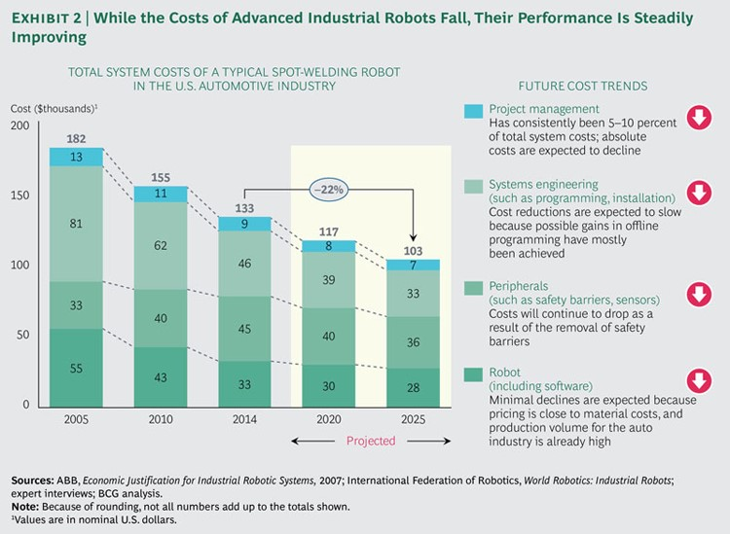

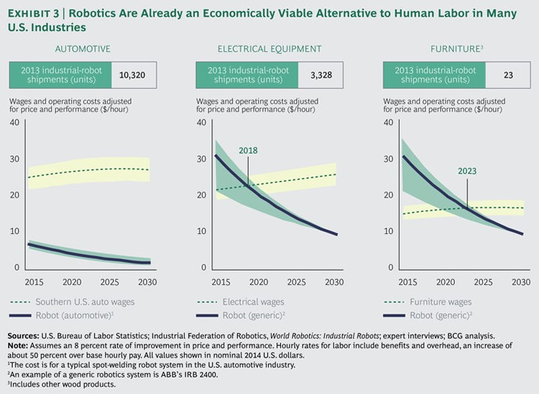

One industry with particularly drastic social and economic prospects is the truck-driving industry. The disruption of the truck driving industry will impact the country on an order of magnitude we have not seen since the construction of the interstate highway system.
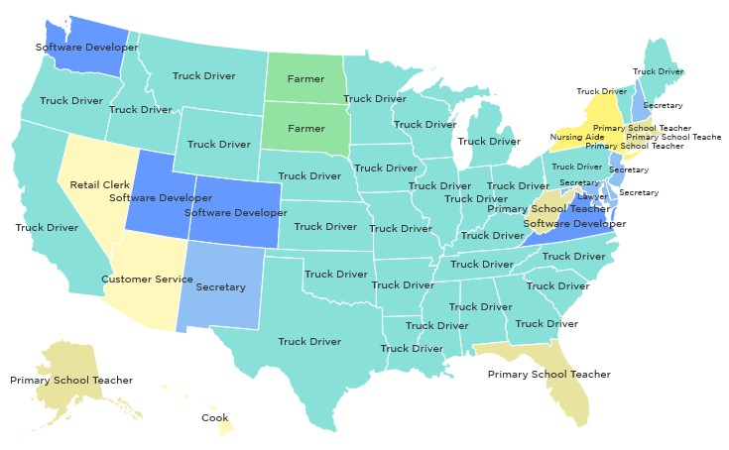

According to the American Truck Driving Association, there are 3.5 million professional truck drivers in the US and an additional 5.2 million people employed in the truck-driving industry who don’t drive the trucks. As those 3.5 million drivers travel the country, they stop periodically to eat, drink, rest and sleep creating a customer base that many businesses in small towns rely on.

Truck drivers act as a vehicle by which money flows from the metropolitan centers to rural communities. The steady stream of drivers subsidizes the wages of rural workers at places like gas stations, motels and diners. Those workers then spend their money in their local community. Reducing the flow of truck drivers invariably shrinks small economies along every major interstate.

From a technical standpoint, truck driving has been nearly perfected. Self-driving cars have the most trouble city driving where turns and traffic present unique challenges. Long-haul truck driving on the other hand, which is the most dangerous for human drivers proves the ideal situation for currently self-driving car technology. A hybrid self-driving with driver assist has already been implemented in Nevada. The Daimler “AU 010” began operating in Nevada on May 6, 2015. In between cities, the truck drives itself while the driver enjoys the ride. If it needs help, it alerts the driver and if the driver doesn’t respond, it pulls over and waits for further instruction.

Also, it’s not just manufacturing or truck driving jobs. A new analysis by the Institute for Spatial Economic Analysis at the University of Redlands suggests that the most susceptible areas to automation in the upcoming years are places with high concentrations of jobs in food preparation, office or administrative support, and/or sales. In Las Vegas and the Riverside-San Bernardino area, it’s predicted that 65% and 63% of jobs respectively will be automatable by 2025. Other areas vulnerable include El Paso, Orlando and Louisville. The authors also warn that almost all large metropolitan areas could lose more than 55% of their current jobs to automation in the next two decades. Using machine learning, programmers can use huge data sets to program robots how to perform non-routine tasks threatening not just the middle-class manufacturing jobs, but also the low-paying jobs as well. With more low-paying jobs eliminated, low-skilled workers who already don’t make much money, will have to compete for fewer and fewer jobs.

While trucking may be in a particular precarious position, almost half of the activities people are paid to do in the global economy have the potential to be automated by adapting currently demonstrated technology. While less than 5% of all occupations can be automated entirely today, about 60% of all occupations have at least 30% of constituent activities that could be automated. While processing/collecting data, performing physical activities and operating machinery in predictable environment have a high technical potential for automation, the susceptibility is significantly lower for other activities such as interfacing with stakeholders, applying expertise to decision making, planning, and creative tasks or managing and developing people.

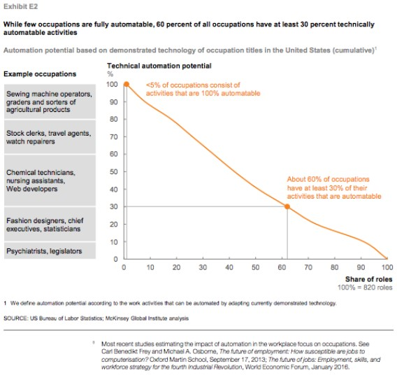
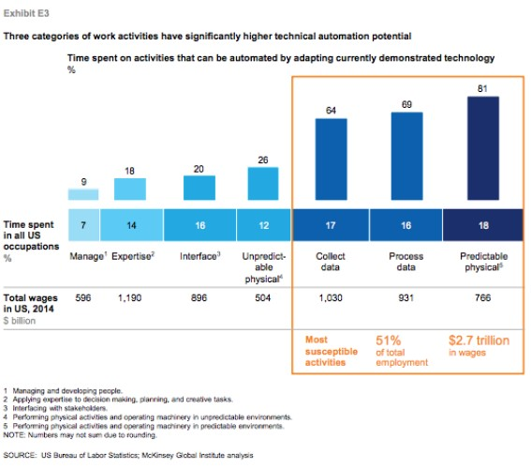

Nearly one-fifth of the time spent in US workplaces involves predictable physical activity which is prevalent in sectors such as manufacturing and retail trade.

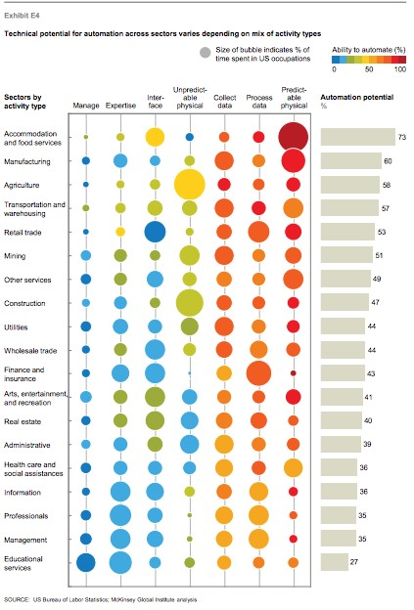

Within sectors, too, there is considerable variation in the potential for automation. In manufacturing, for example, factory welders, cutters, and solderers—occupations that have a large proportion of physical activities in predictable environments—have a technical automation potential above 90% based on adapting currently developed technologies, whereas for customer service that susceptibility is less than 30%.

Overall automation threatens low wage/skill workers most, but essentially all occupations, have some technical automation potential, including CEOs, where 25% of their work could potentially be automated, namely analyzing reports and data to inform decisions, reviewing status reports, preparing staff assignments, and so on.

Automation will cause significant labor displacement and could exacerbate a growing skills and employment gap that already exists between high-skill and low-skill workers. Also, many occupations could be partially automated before they are fully automated, which could have different implications for high and low-skill workers. Low skill workers could see their wages depressed unless demand grows.

Key Issues/Questions

Taxes
Automation and robots oftentimes lower costs while raising production. A factory worker making $50,000 a year pays a portion to their federal, state and local governments in taxes every year that they work. Robots on the other hand don’t pay taxes which will have unforeseen tax revenue implications. Should the government tax robots comparably to how the workers they replace were taxed? Should the government subsidize the automation of businesses or industries?

Jobs
The looming possibilities of automation raise questions about how much and how fast can the U.S. society. Are U.S. institutions and social safety nets equipped to handle massive disruptions to the workplace? What happens to workers whose skills become obsolete? Should there be protections for automation displacement such as with trade? Should the government leverage automation for its own operations? How do we ensure that the prosperity of automation equitably benefits all Americans and not just those at the top? How will we train the next generation of workers for the jobs of the future?

Security
What risks does having a more technologically controlled economy pose? How do we safeguard against those risks? We have seen on several occasions cars used as weapons of terror (Charlottesville, Barcelona, etc.). We have also seen smart devices infiltrated by hackers. How can we ensure that self-driving cars don’t become prey to hackers?

Key Policies of your Committee

The Self-Drive Act

Immigration

Brief Background

With the notable exceptions of Black Americans forcibly brought here as slaves and the Native Americans already residing here, the United States is a nation of immigrants. Immigration has occurred throughout American history and can generally be divided into three peak periods: the initial settlers to the colonies, westward expansion during the middle of the 19th century, and the rise of cities at the turn of the 20th century. We are currently experiencing a fourth peak period of immigration that began in the 1980s and continues today.

While Americans take great pride in their nation-of-immigrants heritage, many approach immigration with deep unease. Each peak era of immigration has sparked tumultuous social changes and political reactions. Each peak era has had far-reaching consequences in shaping the American character, identity, economy, and society, yet each era has resulted in dramatic improvements in America’s prosperity and well-being that would not have been possible without large-scale immigration.

Immigration is necessary to keep up with the pace of job creation in the US economy. Over the last 45 years, a massive increase in native-born 25- to 54-year old workers, particularly women and baby boomers, came into the workforce. This age group accounted for the majority of labor force growth between 1980 and 2000. Since 2000, there has been no net increase in native-born workers aged 25 to 54. There have been sufficient native-born workers entering the workforce to replace retiring workers, the growth in the labor force will not be met by such workers. Infusions of young, tax-paying immigrants are an important part of addressing the shortfalls that lie ahead in terms of numbers of high-and low-skilled workers in social insurance programs.

Immigration fills gaps in the American workforce across the skills spectrum—from the lowest skilled jobs to the highest skilled fields. As more Americans graduate high school and college, there will be fewer and fewer native-born workers available for low-skilled jobs.

While about one-quarter of the foreign-born in the United States have a bachelor’s degree or more, one-third have not completed high school, and thus become the labor pool for the hundreds of thousands of essential jobs that require relatively few skills.

Immigration has helped fuel entrepreneurship that has helped make the US economy the most successful in the world. Entrepreneurs are primary source of innovation, and small businesses generate two out of every three new jobs in the US economy. Entrepreneurs also account for many of the adaptations to changing market conditions that keep the economy flexible and competitive. The risk-taking that motivates people to migrate frequently translates into entrepreneurship. Immigrants are more likely to be self-employed than the native-born.

Despite the considerable benefits of immigration, the US immigration system is broken and outdated. The level of illegal immigration indicates this. There are currently an estimated 11 million undocumented immigrants in the United States. Unauthorized immigrants represented 3.4% of the total U.S. population in 2015.
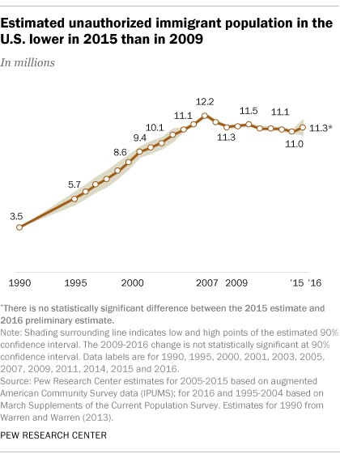

Illegal immigration is primarily a response to laws of supply and demand – workers filling workforce openings—that have proven more powerful than immigration enforcement. Illegal immigration is not a new phenomenon. In 1986, when the undocumented population was estimated to be four to six million, Congress enacted legislation that made it illegal for employers to hire immigrants who were undocumented. Combined with border control and legalization of the illegal population that had been in the country for at least five years the goal was to “wipe the slate clean” for effective immigration control.

In practice, the legislation failed to solve the problem of illegal immigration. Employer enforcement proved difficult because fraudulent documents became readily available, and the legislation did not mandate a reliable way for employers to verify the legal status of those they were hiring. Serious efforts to strengthen border enforcement did not begin until a decade later. Although legalization resulted in about 2.8 million people being able to obtain legal status and ultimately permanent residency, those who were here for less than five years still stayed. The 1986 law did not anticipate the deep changes in labor markets, demographics and the pace of globalization that were just ahead.

The core goals of the legal immigration selection system are family reunification and meeting labor market demands. Both goals are rarely realized. Immigrants who try to immigrate legally are constrained by immigration category caps, as well as caps that limit each country to no more than 7% of the total number of annual worldwide visas (approximately 25,600). The country caps are supposed to prevent high-demand countries from dominating others, but it has led to unreasonable delays for employers and family unification applicants from countries such as Mexico, China, India and the Philippines. In March 2017, the U.S. government was still processing some familysponsored visa applications dating to August 1993, and some employment-related visa applications from March 2005. According to data, there were about 4.4 million applicants (including spouses and minor children) who were on the waiting list as of November 1, 2016. The overwhelming majority (4.3 million) were family-sponsored applicants. About 107,000 were employmentsponsored applicants and their families. In addition to being inhumane, such waits mean that a large portion of an individuals’ productive working years that make immigration a good investment will have passed by the time many ever arrive in the United States.

Delays in employment-based immigration mean that the system often fails to meet labor market needs. Inflexible statutory ceilings, limits in allocation of numbers to high-demand countries, and overly complex procedures all contribute to employers not getting workers when they need them. Skilled workers and professionals with a job offer may wait five years for a visa. Persons of “exceptional ability” may have to wait over three years for an employment visa if they are from India. Visa supply is also a poor fit with demand. Just 5,000 visas are available worldwide each year for low-skilled workers, yet before the Great Recession as many as 500,000 unauthorized immigrants were added to the nation’s population each year, the majority of whom work, mostly in low-wage jobs.
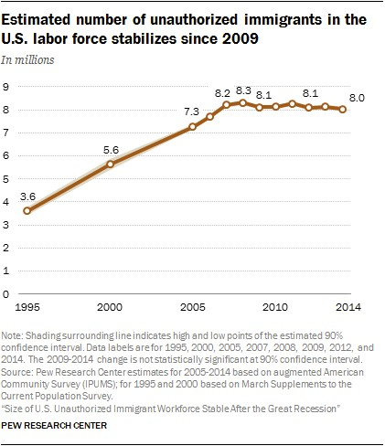
The U.S. civilian workforce includes approximately 8 million unauthorized immigrants, accounting for 5% of those who were working or were unemployed and looking for work.

The belief that immigrants take jobs from American workers and depress their wages is one of the most widely felt fears about immigration. However, immigrants may not actually be having that effect. The impact of immigrant labor on the wages of native-born workers is low and undocumented workers often work the unpleasant, back-breaking jobs that native-born workers are not willing to do. Many of the jobs occupied by the undocumented workers are physically demanding jobs that Americans do not want, such as gutting fish or work on farm fields.
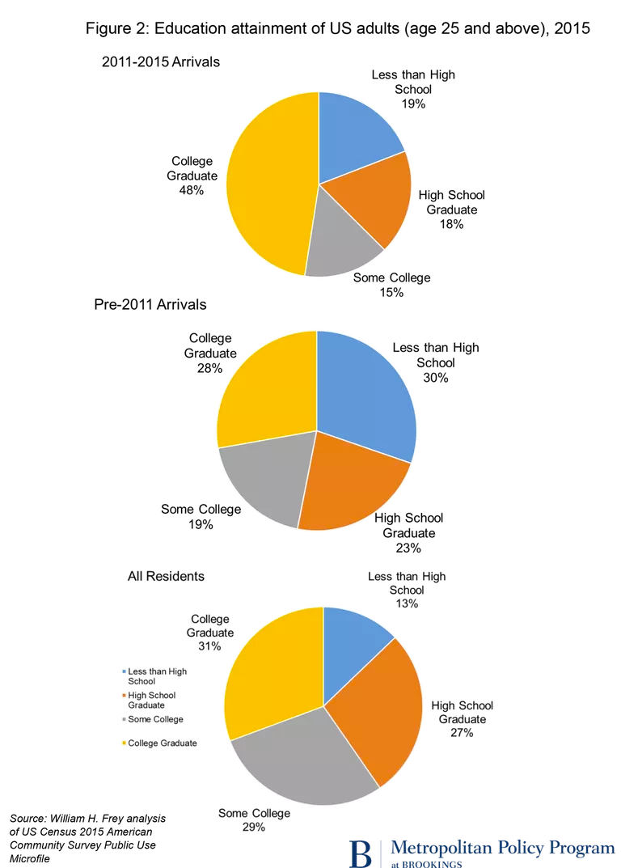

Recent immigrants to the US are already more highly educated than those of the past. Since 2010, nearly half (48%) of recently arrived immigrants are college graduates, compared with only 28% of those who arrived before, and fewer have not received a high school education (19%) than among those who arrived previously (30%). High-skilled immigrants, especially in technology and science, who have come in larger numbers in recent years, had a significant “positive impact” on Americans with skills, and also on working-class Americans, spurring innovation and helping to create jobs.

Immigration has a mixed impact on government budgets. In the first generation, newcomers generally cost governments more than they contribute in taxes, with most of the costs falling on state and local governments—mainly spent educating the children of immigrant families. Annually, first-generation immigrants costs states and localities about $57 billion. However, by the second generation in those families, immigrants become benefit to government coffers, adding about $30 billion a year and by the third generation, immigrant families contribute about $223 billion a year to government finances.

Key Issues/Questions
What does the country do with the 11 million unauthorized immigrants currently residing in the United States?
How do we support families going through the immigration process?
How do we ensure that the legal immigration system is sufficiently robust to meet the needs of the American economy, does not put native-born workers at disadvantage, and does not encourage new waves of illegal immigration?
How do we fully prepare immigrants to fully participate in American life?
How do we secure the United States border?
How do we strengthen immigration enforcement in other areas of border security, especially legal ports of entry (air, land, and sea).

Key Policies of your Committee
The Immigration Reform and Control Act (IRCA)
the “Gang of Eight” – Border Security, Economic Opportunity and Immigration Modernization Act

Suggested Resources
Criminal Justice
Duvernay, Ava, creators. “13th.” Netflix. https://www.netflix.com/watch/80091741.
Automation:
Manyika, James, Chui, Michael, Miremadi, Mehdi, Bughin, Jacques, George, Katy, Willmott, Paul, Dewhurst, Martin. “Harnessing automation for a future that works.” McKinsey.org.
https://www.mckinsey.com/global-themes/digital-disruption/harnessing-automation-for-a-futurethat-works (accessed on September 3, 2017).
Immigration:
National Academies of Sciences, Engineering, and Medicine. 2017. The Economic and Fiscal Consequences of Immigration. Washington, DC: The National Academies Press. https://doi.org/10.17226/23550.
Meissner, Doris, Meyers, Deborah W., Papademetriou, Demetrios G., Fix, Michael. “Immigration and America's Future: A New Chapter.” MigrationPolicy.com. http://www.migrationpolicy.org/research/immigration-and-americas-future-new-chapter (accessed on September 3, 2017).

Character List
Alexander, Lamar - (R - TN)
Class II
455 Dirksen Senate Office Building Washington DC 20510
(202) 224-4944
Contact: www.alexander.senate.gov/public/index.cfm?p=Email

Baldwin, Tammy - (D - WI)
Class I
709 Hart Senate Office Building Washington DC 20510
(202) 224-5653
Contact: www.baldwin.senate.gov/feedback

Barrasso, John - (R - WY)
Class I
307 Dirksen Senate Office Building Washington DC 20510
(202) 224-6441
Contact: www.barrasso.senate.gov/public/index.cfm/contact-form

Bennet, Michael F. - (D - CO)
Class III
261 Russell Senate Office Building Washington DC 20510
(202) 224-5852
Contact: www.bennet.senate.gov/public/index.cfm/contact

Blackburn, Marsha - (R - TN)
Class I
357 Dirksen Senate Office Building Washington DC 20510
(202) 224-3344
Contact: www.blackburn.senate.gov/contact_marsha

Blumenthal, Richard - (D - CT)
Class III
706 Hart Senate Office Building Washington DC 20510
(202) 224-2823
Contact: www.blumenthal.senate.gov/contact/

Blunt, Roy - (R - MO)
Class III
260 Russell Senate Office Building Washington DC 20510
(202) 224-5721
Contact: www.blunt.senate.gov/public/index.cfm/contact-roy

Booker, Cory A. - (D - NJ)
Class II
717 Hart Senate Office Building Washington DC 20510
(202) 224-3224
Contact: www.booker.senate.gov/?p=contact

Boozman, John - (R - AR)
Class III
141 Hart Senate Office Building Washington DC 20510
(202) 224-4843
Contact: www.boozman.senate.gov/public/index.cfm/contact

Braun, Mike - (R - IN)
Class I
374 Russell Senate Office Building Washington DC 20510
(202) 224-4814
Contact: www.braun.senate.gov/contact-mike

Brown, Sherrod - (D - OH)
Class I
503 Hart Senate Office Building Washington DC 20510
(202) 224-2315
Contact: www.brown.senate.gov/contact/

Burr, Richard - (R - NC)
Class III
217 Russell Senate Office Building Washington DC 20510
(202) 224-3154
Contact: www.burr.senate.gov/contact/email

Cantwell, Maria - (D - WA)
Class I
511 Hart Senate Office Building Washington DC 20510
(202) 224-3441
Contact: www.cantwell.senate.gov/public/index.cfm/email-maria

Capito, Shelley Moore - (R - WV)
Class II
172 Russell Senate Office Building Washington DC 20510
(202) 224-6472
Contact: www.capito.senate.gov/contact/contact-shelley

Cardin, Benjamin L. - (D - MD)
Class I
509 Hart Senate Office Building Washington DC 20510
(202) 224-4524
Contact: www.cardin.senate.gov/contact/

Carper, Thomas R. - (D - DE)
Class I
513 Hart Senate Office Building Washington DC 20510
(202) 224-2441
Contact: www.carper.senate.gov/public/index.cfm/email-senator-carper

Casey, Robert P., Jr. - (D - PA)
Class I
393 Russell Senate Office Building Washington DC 20510
(202) 224-6324
Contact: www.casey.senate.gov/contact/

Cassidy, Bill - (R - LA)
Class II
520 Hart Senate Office Building Washington DC 20510
(202) 224-5824
Contact: www.cassidy.senate.gov/contact

Collins, Susan M. - (R - ME)
Class II
413 Dirksen Senate Office Building Washington DC 20510
(202) 224-2523
Contact: www.collins.senate.gov/contact

Coons, Christopher A. - (D - DE)
Class II
218 Russell Senate Office Building Washington DC 20510
(202) 224-5042
Contact: www.coons.senate.gov/contact

Cornyn, John - (R - TX)
Class II
517 Hart Senate Office Building Washington DC 20510
(202) 224-2934
Contact: www.cornyn.senate.gov/contact

Cortez Masto, Catherine - (D - NV)
Class III
516 Hart Senate Office Building Washington DC 20510
(202) 224-3542
Contact: www.cortezmasto.senate.gov/contact

Cotton, Tom - (R - AR)
Class II
326 Russell Senate Office Building Washington DC 20510
(202) 224-2353
Contact: www.cotton.senate.gov/?p=contact

Cramer, Kevin - (R - ND)
Class I
400 Russell Senate Office Building Washington DC 20510
(202) 224-2043
Contact: www.cramer.senate.gov/contact_kevin

Crapo, Mike - (R - ID)
Class III
239 Dirksen Senate Office Building Washington DC 20510
(202) 224-6142
Contact: www.crapo.senate.gov/contact

Cruz, Ted - (R - TX)
Class I
127A Russell Senate Office Building Washington DC 20510
(202) 224-5922
Contact: www.cruz.senate.gov/?p=form&id=16

Daines, Steve - (R - MT)
Class II
320 Hart Senate Office Building Washington DC 20510
(202) 224-2651
Contact: www.daines.senate.gov/connect/email-steve

Duckworth, Tammy - (D - IL)
Class III
524 Hart Senate Office Building Washington DC 20510
(202) 224-2854
Contact: www.duckworth.senate.gov/content/contact-senator

Durbin, Richard J. - (D - IL)
Class II
711 Hart Senate Office Building Washington DC 20510
(202) 224-2152
Contact: www.durbin.senate.gov/contact/

Enzi, Michael B. - (R - WY)
Class II
379A Russell Senate Office Building Washington DC 20510
(202) 224-3424
Contact: www.enzi.senate.gov/public/index.cfm/contact?p=e-mail-sen...

Ernst, Joni - (R - IA)
Class II
730 Hart Senate Office Building Washington DC 20510
(202) 224-3254
Contact: www.ernst.senate.gov/public/index.cfm/contact

Feinstein, Dianne - (D - CA)
Class I
331 Hart Senate Office Building Washington DC 20510
(202) 224-3841
Contact: www.feinstein.senate.gov/public/index.cfm/e-mail-me

Fischer, Deb - (R - NE)
Class I
454 Russell Senate Office Building Washington DC 20510
(202) 224-6551
Contact: www.fischer.senate.gov/public/index.cfm/contact

Gardner, Cory - (R - CO)
Class II
354 Russell Senate Office Building Washington DC 20510
(202) 224-5941
Contact: www.gardner.senate.gov/contact-cory/email-cory

Gillibrand, Kirsten E. - (D - NY)
Class I
478 Russell Senate Office Building Washington DC 20510
(202) 224-4451
Contact: www.gillibrand.senate.gov/contact/email-me

Graham, Lindsey - (R - SC)
Class II
290 Russell Senate Office Building Washington DC 20510
(202) 224-5972
Contact: www.lgraham.senate.gov/public/index.cfm/e-mail-senator-gr...

Grassley, Chuck - (R - IA)
Class III
135 Hart Senate Office Building Washington DC 20510
(202) 224-3744
Contact: www.grassley.senate.gov/contact

Harris, Kamala D. - (D - CA)
Class III
112 Hart Senate Office Building Washington DC 20510
(202) 224-3553
Contact: www.harris.senate.gov/contact

Hassan, Margaret Wood - (D - NH)
Class III
324 Hart Senate Office Building Washington DC 20510
(202) 224-3324
Contact: www.hassan.senate.gov/content/contact-senator

Hawley, Josh - (R - MO)
Class I
212 Russell Senate Office Building Washington DC 20510
(202) 224-6154
Contact: www.hawley.senate.gov/contact-senator-hawley

Heinrich, Martin - (D - NM)
Class I
303 Hart Senate Office Building Washington DC 20510
(202) 224-5521
Contact: www.heinrich.senate.gov/contact

Hirono, Mazie K. - (D - HI)
Class I
713 Hart Senate Office Building Washington DC 20510
(202) 224-6361
Contact: www.hirono.senate.gov/contact

Hoeven, John - (R - ND)
Class III
338 Russell Senate Office Building Washington DC 20510
(202) 224-2551
Contact: www.hoeven.senate.gov/public/index.cfm/email-the-senator

Hyde-Smith, Cindy - (R - MS)
Class II
702 Hart Senate Office Building Washington DC 20510
(202) 224-5054
Contact: www.hydesmith.senate.gov/content/contact-senator

Inhofe, James M. - (R - OK)
Class II
205 Russell Senate Office Building Washington DC 20510
(202) 224-4721
Contact: www.inhofe.senate.gov/contact

Johnson, Ron - (R - WI)
Class III
328 Hart Senate Office Building Washington DC 20510
(202) 224-5323
Contact: www.ronjohnson.senate.gov/public/index.cfm/email-the-sena...

Jones, Doug - (D - AL)
Class II
330 Hart Senate Office Building Washington DC 20510
(202) 224-4124
Contact: www.jones.senate.gov/content/contact-senator

Kaine, Tim - (D - VA)
Class I
231 Russell Senate Office Building Washington DC 20510
(202) 224-4024
Contact: www.kaine.senate.gov/contact

Kennedy, John - (R - LA)
Class III
416 Russell Senate Office Building Washington DC 20510
(202) 224-4623
Contact: www.kennedy.senate.gov/public/email-me

King, Angus S., Jr. - (I - ME)
Class I
133 Hart Senate Office Building Washington DC 20510
(202) 224-5344
Contact: www.king.senate.gov/contact

Klobuchar, Amy - (D - MN)
Class I
425 Dirksen Senate Office Building Washington DC 20510
(202) 224-3244
Contact: www.klobuchar.senate.gov/public/index.cfm/contact

Lankford, James - (R - OK)
Class III
316 Hart Senate Office Building Washington DC 20510
(202) 224-5754
Contact: www.lankford.senate.gov/contact/email

Leahy, Patrick J. - (D - VT)
Class III
437 Russell Senate Office Building Washington DC 20510
(202) 224-4242
Contact: www.leahy.senate.gov/contact/

Lee, Mike - (R - UT)
Class III
361A Russell Senate Office Building Washington DC 20510
(202) 224-5444
Contact: www.lee.senate.gov/public/index.cfm/contact

Loeffler, Kelly - (R - GA)
Class III
B85 Russell Senate Office Building Washington DC 20510
(202) 224-3643
Contact: www.loeffler.senate.gov

Manchin, Joe, III - (D - WV)
Class I
306 Hart Senate Office Building Washington DC 20510
(202) 224-3954
Contact: www.manchin.senate.gov/public/index.cfm/contact-form

Markey, Edward J. - (D - MA)
Class II
255 Dirksen Senate Office Building Washington DC 20510
(202) 224-2742
Contact: www.markey.senate.gov/contact

McConnell, Mitch - (R - KY)
Class II
317 Russell Senate Office Building Washington DC 20510
(202) 224-2541
Contact: www.mcconnell.senate.gov/public/index.cfm?p=contact

McSally, Martha - (R - AZ)
Class III
404 Russell Senate Office Building Washington DC 20510
202-224-2235
Contact: www.mcsally.senate.gov/contact_martha

Menendez, Robert - (D - NJ)
Class I
528 Hart Senate Office Building Washington DC 20510
(202) 224-4744
Contact: www.menendez.senate.gov/contact

Merkley, Jeff - (D - OR)
Class II
313 Hart Senate Office Building Washington DC 20510
(202) 224-3753
Contact: www.merkley.senate.gov/contact/

Moran, Jerry - (R - KS)
Class III
521 Dirksen Senate Office Building Washington DC 20510
(202) 224-6521
Contact: www.moran.senate.gov/public/index.cfm/e-mail-jerry

Murkowski, Lisa - (R - AK)
Class III
522 Hart Senate Office Building Washington DC 20510
(202) 224-6665
Contact: www.murkowski.senate.gov/public/index.cfm/contact

Murphy, Christopher - (D - CT)
Class I
136 Hart Senate Office Building Washington DC 20510
(202) 224-4041
Contact: www.murphy.senate.gov/contact

Murray, Patty - (D - WA)
Class III
154 Russell Senate Office Building Washington DC 20510
(202) 224-2621
Contact: www.murray.senate.gov/public/index.cfm/contactme

Paul, Rand - (R - KY)
Class III
167 Russell Senate Office Building Washington DC 20510
(202) 224-4343
Contact: www.paul.senate.gov/connect/email-rand

Perdue, David - (R - GA)
Class II
455 Russell Senate Office Building Washington DC 20510
(202) 224-3521
Contact: www.perdue.senate.gov/connect/email

Peters, Gary C. - (D - MI)
Class II
724 Hart Senate Office Building Washington DC 20510
(202) 224-6221
Contact: www.peters.senate.gov/contact/email-gary

Portman, Rob - (R - OH)
Class III
448 Russell Senate Office Building Washington DC 20510
(202) 224-3353
Contact: www.portman.senate.gov/public/index.cfm/contact?p=contact...

Reed, Jack - (D - RI)
Class II
728 Hart Senate Office Building Washington DC 20510
(202) 224-4642
Contact: www.reed.senate.gov/contact/

Risch, James E. - (R - ID)
Class II
483 Russell Senate Office Building Washington DC 20510
(202) 224-2752
Contact: www.risch.senate.gov/public/index.cfm?p=Email

Roberts, Pat - (R - KS)
Class II
109 Hart Senate Office Building Washington DC 20510
(202) 224-4774
Contact: www.roberts.senate.gov/public/?p=EmailPat

Romney, Mitt - (R - UT)
Class I
124 Russell Senate Office Building Washington DC 20510
(202) 224-5251
Contact: www.romney.senate.gov/contact-senator-romney

Rosen, Jacky - (D - NV)
Class I
144 Russell Senate Office Building Washington DC 20510
(202) 224-6244
Contact: www.rosen.senate.gov/contact_jacky

Rounds, Mike - (R - SD)
Class II
502 Hart Senate Office Building Washington DC 20510
(202) 224-5842
Contact: www.rounds.senate.gov/contact/email-mike

Rubio, Marco - (R - FL)
Class III
284 Russell Senate Office Building Washington DC 20510
(202) 224-3041
Contact: www.rubio.senate.gov/public/index.cfm/contact

Sanders, Bernard - (I - VT)
Class I
332 Dirksen Senate Office Building Washington DC 20510
(202) 224-5141
Contact: www.sanders.senate.gov/contact/

Sasse, Ben - (R - NE)
Class II
107 Russell Senate Office Building Washington DC 20510
(202) 224-4224
Contact: www.sasse.senate.gov/public/index.cfm/email-ben

Schatz, Brian - (D - HI)
Class III
722 Hart Senate Office Building Washington DC 20510
(202) 224-3934
Contact: www.schatz.senate.gov/contact

Schumer, Charles E. - (D - NY)
Class III
322 Hart Senate Office Building Washington DC 20510
(202) 224-6542
Contact: www.schumer.senate.gov/contact/email-chuck

Scott, Rick - (R - FL)
Class I
716 Hart Senate Office Building Washington DC 20510
(202) 224-5274
Contact: www.rickscott.senate.gov/contact_rick

Scott, Tim - (R - SC)
Class III
104 Hart Senate Office Building Washington DC 20510
(202) 224-6121
Contact: www.scott.senate.gov/contact/email-me

Shaheen, Jeanne - (D - NH)
Class II
506 Hart Senate Office Building Washington DC 20510
(202) 224-2841
Contact: www.shaheen.senate.gov/contact/contact-jeanne

Shelby, Richard C. - (R - AL)
Class III
304 Russell Senate Office Building Washington DC 20510
(202) 224-5744
Contact: www.shelby.senate.gov/public/index.cfm/emailsenatorshelby

Sinema, Kyrsten - (D - AZ)
Class I
317 Hart Senate Office Building Washington DC 20510
(202) 224-4521
Contact: www.sinema.senate.gov/contact-kyrsten

Smith, Tina - (D - MN)
Class II
720 Hart Senate Office Building Washington DC 20510
(202) 224-5641
Contact: www.smith.senate.gov/contact-tina

Stabenow, Debbie - (D - MI)
Class I
731 Hart Senate Office Building Washington DC 20510
(202) 224-4822
Contact: www.stabenow.senate.gov/contact

Sullivan, Dan - (R - AK)
Class II
302 Hart Senate Office Building Washington DC 20510
(202) 224-3004
Contact: www.sullivan.senate.gov/contact/email

Tester, Jon - (D - MT)
Class I
311 Hart Senate Office Building Washington DC 20510
(202) 224-2644
Contact: www.tester.senate.gov/?p=email_senator

Thune, John - (R - SD)
Class III
511 Dirksen Senate Office Building Washington DC 20510
(202) 224-2321
Contact: www.thune.senate.gov/public/index.cfm/contact

Tillis, Thom - (R - NC)
Class II
113 Dirksen Senate Office Building Washington DC 20510
(202) 224-6342
Contact: www.tillis.senate.gov/public/index.cfm/email-me

Toomey, Patrick J. - (R - PA)
Class III
248 Russell Senate Office Building Washington DC 20510
(202) 224-4254
Contact: www.toomey.senate.gov/?p=contact

Udall, Tom - (D - NM)
Class II
531 Hart Senate Office Building Washington DC 20510
(202) 224-6621
Contact: www.tomudall.senate.gov/?p=contact

Van Hollen, Chris - (D - MD)
Class III
110 Hart Senate Office Building Washington DC 20510
(202) 224-4654
Contact: www.vanhollen.senate.gov/contact/email

Warner, Mark R. - (D - VA)
Class II
703 Hart Senate Office Building Washington DC 20510
(202) 224-2023
Contact: www.warner.senate.gov/public/index.cfm?p=Contact

Warren, Elizabeth - (D - MA)
Class I
309 Hart Senate Office Building Washington DC 20510
(202) 224-4543
Contact: www.warren.senate.gov/?p=email_senator

Whitehouse, Sheldon - (D - RI)
Class I
530 Hart Senate Office Building Washington DC 20510
(202) 224-2921
Contact: www.whitehouse.senate.gov/contact/email-sheldon

Wicker, Roger F. - (R - MS)
Class I
555 Dirksen Senate Office Building Washington DC 20510
(202) 224-6253
Contact: www.wicker.senate.gov/public/index.cfm/contact

Wyden, Ron - (D - OR)
Class III
221 Dirksen Senate Office Building Washington DC 20510
(202) 224-5244
Contact: www.wyden.senate.gov/contact/

Young, Todd - (R - IN)
Class III
185 Dirksen Senate Office Building Washington DC 20510
(202) 224-5623
Contact: www.young.senate.gov/contact

Bibliography

Samuels, Alana. “The Parts of America Most Susceptible to Automation.” TheAtlantic.com.
https://www.theatlantic.com/business/archive/2017/05/the-parts-of-america-mostsusceptible-to-automation/525168/ (Accessed on September 1, 2017).

“AUTONOMOUS VEHICLES | SELF-DRIVING VEHICLES ENACTED LEGISLATION.” NCLS.org.
http://www.ncsl.org/research/transportation/autonomous-vehicles-self-driving-vehicles-enactedlegislation.aspx (accessed on September 22, 2017).

Santens, Scott. “Self-Driving Trucks Are Going to Hit Us Like a Human-Driven Truck.”
Medium.com. https://medium.com/basic-income/self-driving-trucks-are-going-to-hit-us-like-ahuman-driven-truck-b8507d9c5961 (accessed on September 1, 2017).

Sirkin, Harold L., Zinser, Michael, and Rose, Justin. “How Robots Will Redefine
Competitiveness.” BCGPerspectives.com https://www.bcgperspectives.com/content/articles/leanmanufacturing-innovation-robots-redefine-competitiveness/ (access on September 1, 2017).

“The SELF DRIVE Act.” EnergyCommerce.House.gov. https://energycommerce.house.gov/selfdrive/ (accessed on September 1, 2017).

Da Costa, Pedro Nicolaci. “Robots are going to take a lot of jobs — here's what we could do about it.” BusinessInsider.com. http://www.businessinsider.com/policy-responses-toautomation-and-robots-taking-jobs-2017-4 (accessed on September 1, 2017).

Da Costa, Pedro Nicolaci. “Robots and automation are going white collar — but they're not here to steal your job just yet.” BusinessInsider.com. http://www.businessinsider.com/white-collarjobs-and-automation-2017-3 (accessed on September 1, 2017).

Delaney, Kevin J. “The robot that takes your job should pay taxes, says Bill Gates.” QZ.com. https://qz.com/911968/bill-gates-the-robot-that-takes-your-job-should-pay-taxes/ (accessed on September 1, 2017).

Elliott, Debbie. “Public Defenders Hard To Come By In Louisiana.” http://www.npr.org/2017/03/10/519211293/public-defenders-hard-to-come-by-in-louisiana (accessed on September 3, 2017).

“Louisiana’s public defender system violates the rights of the poor.” Salon.com.
https://www.salon.com/2017/05/30/louisianas-public-defender-system-violates-the-rights-of-thepoor_partner/ (accessed on September 3, 2017).

Eber, Gabriel, Winter, Margaret. “Private Prisons Are the Problem, Not the Solution.” ACLU.org.
https://www.aclu.org/blog/mass-incarceration/private-prisons-are-problem-not-solution (accessed on September 3, 2017).

Winter, Margaret. "A Picture of Such Horror as Should Be Unrealized Anywhere in the Civilized
World." ACLU.org. https://www.aclu.org/blog/mass-incarceration/picture-such-horror-should-beunrealized-anywhere-civilized-world?redirect=blog/prisoners-rights-criminal-lawreform/picture-such-horror-should-be-unrealized-anywhere (accessed on September 3, 2017).

“A Brief History of the Drug War.” DrugPolicy.org. http://www.drugpolicy.org/issues/briefhistory-drug-war (accessed on September 3, 2017).

Lartey, Jamiles. “Women in jails are the fastest growing incarcerated population, study says.” TheGuardian.com. https://www.theguardian.com/us-news/2016/aug/17/women-incarcerationrates-growth-study (accessed on September 3, 2017).

Smith, Clint. “Why the U.S. Is Right to Move Away from Private Prisons.” NewYorker.com. https://www.newyorker.com/news/news-desk/why-the-u-s-is-right-to-move-away-from-privateprisons (accessed on September 3, 2017).

Feige, David. “The Independent Grand Jury That Wasn’t.” Slate.com.
http://www.slate.com/articles/news_and_politics/jurisprudence/2014/11/ferguson_grand_jury_an nouncement_prosecutor_robert_mcculloch_influenced.html (accessed on September 3, 2017).

Hoban, Brennan. “Do immigrants “steal” jobs from American workers?.” Brookings.edu. https://www.brookings.edu/blog/brookings-now/2017/08/24/do-immigrants-steal-jobs-fromamerican-workers/

Giovagnoli, Mary. “Overhauling Immigration Law: A Brief History and Basic Principles of Reform.” AmericanImmigrationCouncil.org.
https://www.americanimmigrationcouncil.org/research/overhauling-immigration-law-briefhistory-and-basic-principles-reform (accessed on September 3, 2017).

Raleigh, Helen. “How To Fix Our Messed-Up Immigration System So It Boosts The Economy.”
TheFederalist.com. http://thefederalist.com/2016/08/08/how-to-fix-our-messed-up-immigrationsystem-so-it-boosts-the-economy/ (accessed on September 3, 2017).

Zong, Jie, Batalova, Jeanne. “Frequently Requested Statistics on Immigrants and Immigration in the United States.” MigrationPolicy.org. http://www.migrationpolicy.org/article/frequentlyrequested-statistics-immigrants-and-immigration-united-states (accessed on September 3, 2017).

Passel, Jeffrey S., Cohn, D’Vera. “As Mexican share declined, U.S. unauthorized immigrant population fell in 2015 below recession level.” PewResearch.org.
http://www.pewresearch.org/fact-tank/2017/04/25/as-mexican-share-declined-u-s-unauthorizedimmigrant-population-fell-in-2015-below-recession-level/ (accessed on September 3, 2017).
Manyika, James, Chui, Michael, Miremadi, Mehdi, Bughin, Jacques, George, Katy, Willmott, Paul, Dewhurst, Martin. “Harnessing automation for a future that works.” McKinsey.org. https://www.mckinsey.com/global-themes/digital-disruption/harnessing-automation-for-a-futurethat-works (accessed on September 3, 2017).

